Set 6
Product Sales Analysis
Dataset: Monthly Product Sales

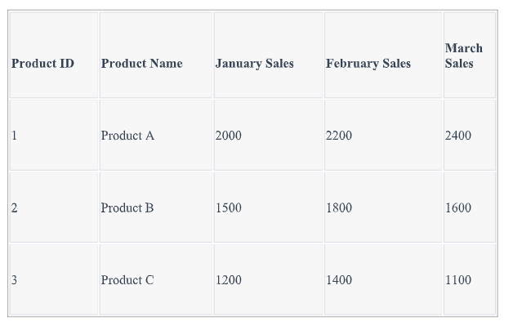1. Create a grouped bar chart to visualize the sales of each product for the first quarter. Label
the chart elements.
Code:
sales_matrix <- rbind(
sales_data$January_Sales,
sales_data$February_Sales,
sales_data$March_Sales
)

colnames(sales_matrix) <- sales_data$Product_Name

rownames(sales_matrix) <- c(
"January",
"February",
"March"
)

barplot(
sales_matrix,
beside = TRUE,
main = "First Quarter Product Sales",
xlab = "Month",
ylab = "Sales",
col = c("skyblue", "lightgreen", "orange"),
legend.text = colnames(sales_matrix)
)
Output:
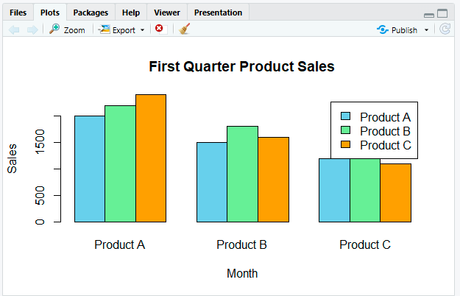
2. Generate a stacked area chart to represent the overall sales trend for all products over the
three months.
Code:
sales_matrix <- t(
as.matrix(
sales_data[, c(
"January_Sales",
"February_Sales",
"March_Sales"
)]
)
)

colnames(sales_matrix) <- sales_data$Product_Name

months <- c(
"January",
"February",
"March"
)

matplot(
1:3,
sales_matrix,
type = "l",
lty = 1,
lwd = 2,
xaxt = "n",
main = "Sales Trend of All Products",
xlab = "Month",
ylab = "Sales"
)

axis(
1,
at = 1:3,
labels = months
)

legend(
"topleft",
legend = colnames(sales_matrix),
lty = 1,
lwd = 2
)

grid()
Output:
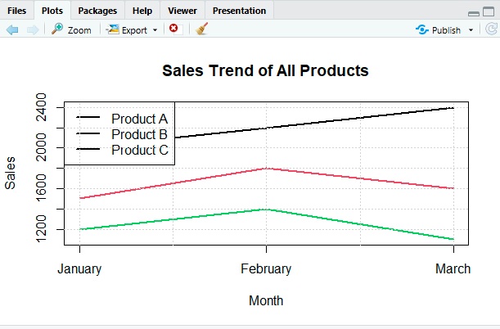
3. Build a table to show the monthly sales data for each product. Label the table elements.
Code:
cumulative_sales <- apply(
sales_matrix,
1,
cumsum
)

plot(
1:3,
cumulative_sales[, 3],
type = "n",
xaxt = "n",
ylim = c(
0,
max(cumulative_sales)
),
main = "Stacked Area Chart of Product Sales",
xlab = "Month",
ylab = "Total Sales"
)

axis(
1,
at = 1:3,
labels = months
)

polygon(
c(1:3, 3:1),
c(
cumulative_sales[, 1],
rep(0, 3)
),
border = NA
)

polygon(
c(1:3, 3:1),
c(
cumulative_sales[, 2],
rev(cumulative_sales[, 1])
),
border = NA
)

polygon(
c(1:3, 3:1),
c(
cumulative_sales[, 3],
rev(cumulative_sales[, 2])
),
border = NA
)

legend(
"topleft",
legend = sales_data$Product_Name,
fill = c("gray70", "gray50", "gray30")
)

grid()
Output:
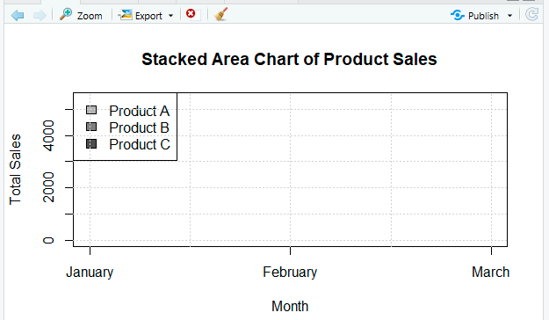
Set 7
Customer Demographics Analysis
Dataset: Customer Demographics

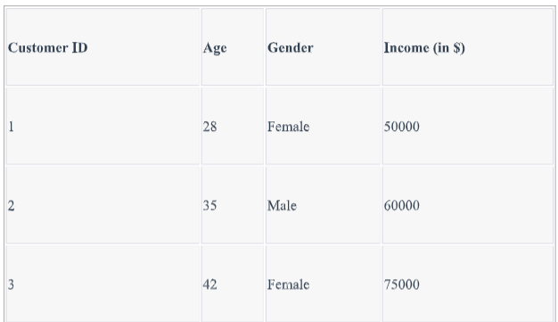
1. Create a bar chart to visualize the distribution of customer ages. Label the axes and
title the chart.
Code:
barplot(
customer_data$Age,
names.arg = paste("Customer", customer_data$Customer_ID),
main = "Distribution of Customer Ages",
xlab = "Customer",
ylab = "Age",
col = "skyblue"
)
Output:
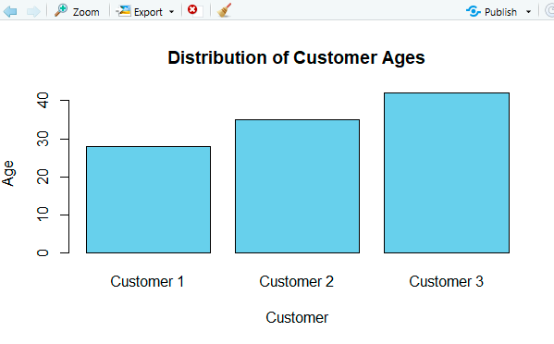

2. Generate a pie chart to represent the distribution of customers by gender.
Code:
gender_count <- table(customer_data$Gender)

pie(
gender_count,
labels = paste(
names(gender_count),
gender_count
),
main = "Distribution of Customers by Gender"
)
Output:
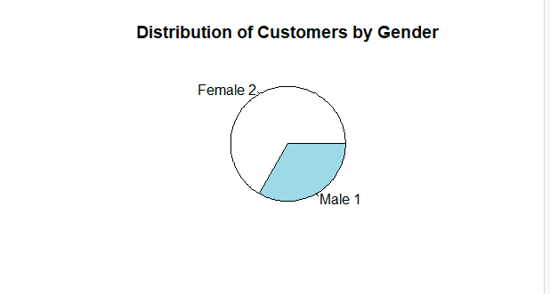
3. Build a table to show the demographic information for each customer. Label the table
elements.
Code:
print(customer_data)
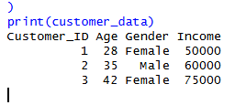
Set8
Employee Performance Analysis
Dataset: Employee Performance

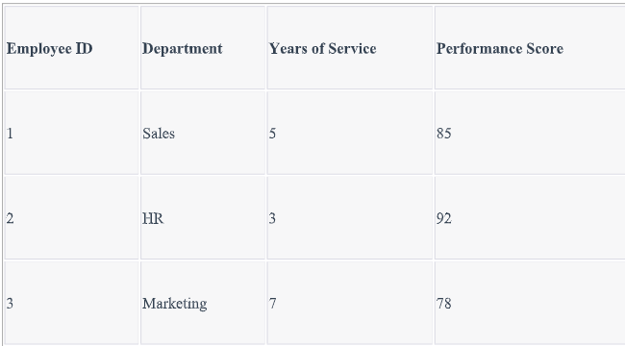
1. Create a line chart to visualize the performance trend of employees over time. Label
the axes and title the chart.
Code:
plot(
employee_data$Years_of_Service,
employee_data$Performance_Score,
type = "o",
pch = 16,
main = "Employee Performance Trend",
xlab = "Years of Service",
ylab = "Performance Score"
)

text(
employee_data$Years_of_Service,
employee_data$Performance_Score,
labels = paste(
"Employee",
employee_data$Employee_ID
),
pos = 3
)

grid()
Output:
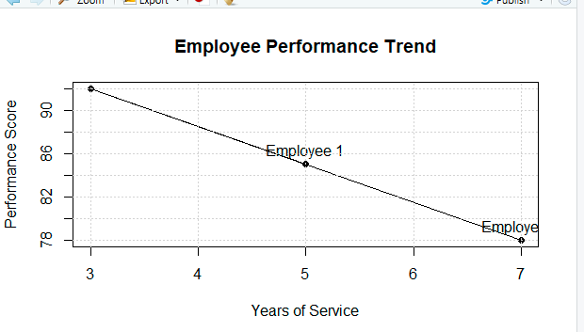

2. Generate a bar chart showing the distribution of employees across different departments.
Label the chart elements.
Code:
department_count <- table(employee_data$Department)

barplot(
department_count,
main = "Distribution of Employees by Department",
xlab = "Department",
ylab = "Number of Employees",
col = "lightgreen"
)
Output:
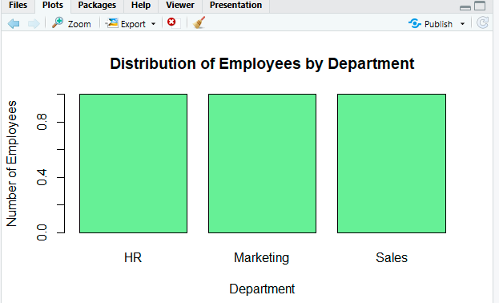
3. Build a table to display the performance data for each employee. Label the table elements.
Code:
print(employee_data)
Output:
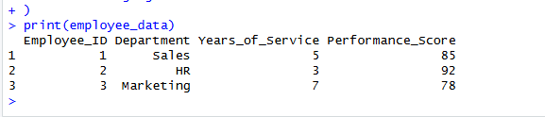

Set 9
Product Inventory Management
Dataset: Product Inventory
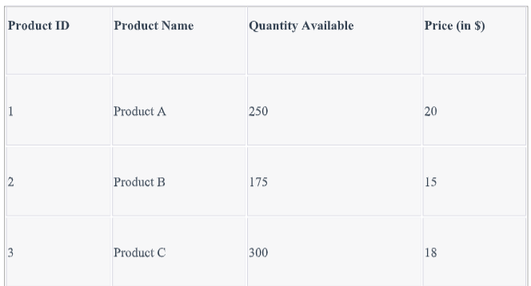1. Create a bar chart to visualize the quantity of each product in the inventory. Label the
axes and title the chart.
Code:
barplot(
inventory_data$Quantity_Available,
names.arg = inventory_data$Product_Name,
main = "Product Inventory Quantity",
xlab = "Product",
ylab = "Quantity Available",
col = "skyblue"
)
Output:
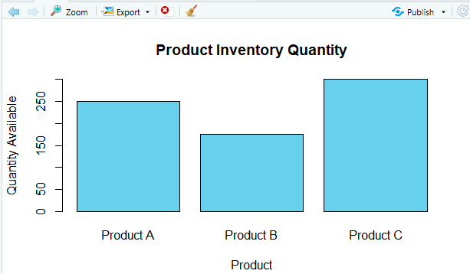

2. Generate a stacked bar chart to show the quantity of each product within different product
categories.
Code:
inventory_data$Category <- c(
"Electronics",
"Electronics",
"Accessories"
)
Output:
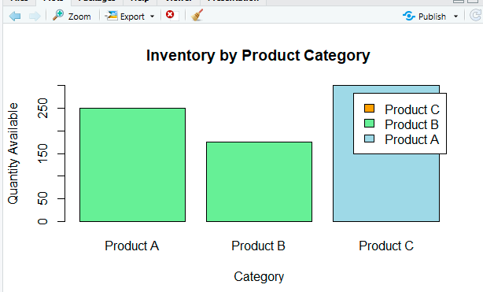
3. Build a table to show the inventory data for each product. Label the table elements.
Code:
print(inventory_data)
Output:
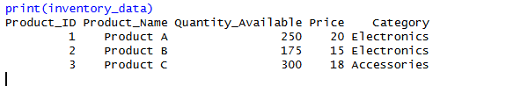
Set 10
Survey Responses Analysis
Dataset: Survey Responses

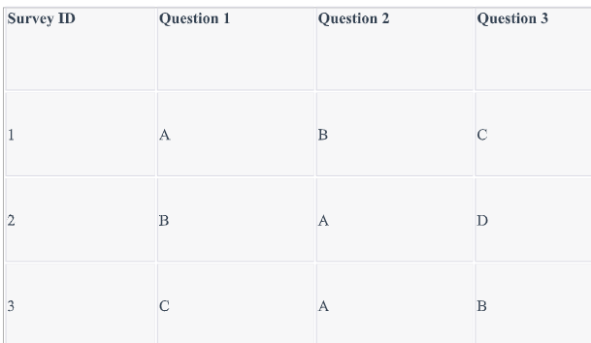
1. Create a grouped bar chart to visualize the distribution of answers for Question 1.
Label the chart elements.
Code:
question1_count <- table(
survey_data$Question_1
)

barplot(
question1_count,
main = "Distribution of Answers for Question 1",
xlab = "Answer",
ylab = "Number of Responses",
col = "skyblue"
)
Output:
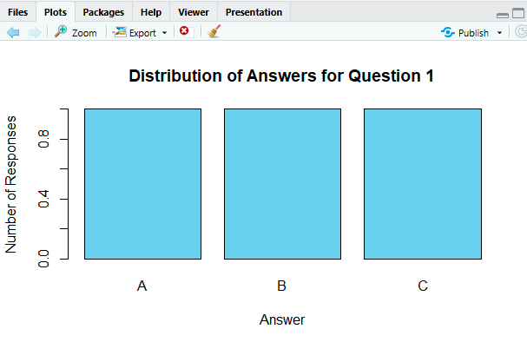
2. Generate a stacked bar chart to represent the overall distribution of responses for all three
questions.
Code:
response_table <- rbind(
Question_1 = table(
factor(
survey_data$Question_1,
levels = c("A", "B", "C", "D")
)
),
Question_2 = table(
factor(
survey_data$Question_2,
levels = c("A", "B", "C", "D")
)
),
Question_3 = table(
factor(
survey_data$Question_3,
levels = c("A", "B", "C", "D")
)
)
)
response_table

Output:
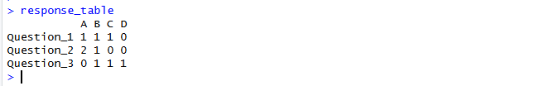
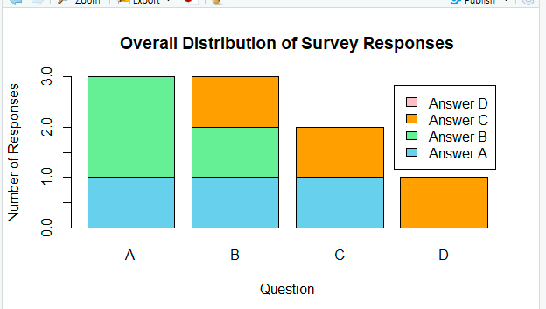
3. Build a table to show the survey response data for each survey. Label the table elements.
Code:
print(survey_data)
Output:
